Creating a SOAP webservice using MuleSoft
-What is webservices:
Web services are communication methods between two or more systems over a network.
There are 2 types of webservices:
1)REST(Representational State Transfer)-is a Architectural Style
2)SOAP(Simple Object Access Protocol)-is a standardized Messaging Protocol
Feature | REST (Representational State Transfer) | SOAP (Simple Object Access Protocol)
Type | Architectural style based on HTTP. | A formal, XML-based protocol with strict rules defined by the W3C.
Data format | Supports multiple lightweight formats, most commonly JSON, but also XML, plain text, and others. | Requires XML, which is more verbose and heavy than JSON.
Performance | Faster and more efficient due to smaller message sizes and support for caching. | Slower due to the larger XML payload and additional overhead.
Transport protocol | Tied to the HTTP protocol. | Protocol-agnostic, and can use HTTP, SMTP, TCP, or others.
Coupling | Loosely coupled, providing more flexibility. Changes to the service often do not break clients. | Tightly coupled, requiring a Web Services Description Language (WSDL) file to define the contract. Changes require clients to update.
Security | Relies on transport-level security like HTTPS, along with authentication methods like OAuth and JSON Web Tokens (JWT). | Has robust, built-in security standards through extensions like WS-Security.
State | Stateless, meaning each request contains all necessary information and no session data is stored on the server. | Stateful or stateless. While often stateless by default, it can support stateful operations for complex transactions.
Ease of use | Simpler to use and requires a smaller learning curve. Can be tested easily in a web browser. | More complex to implement, with a steeper learning curve and more tooling requirements.
Use case example | Public APIs, mobile applications, microservices, and web apps where speed and flexibility are key. | Enterprise-level services, financial and legacy systems, or applications requiring strict security and transactional reliability.

In the real word, we prone to use REST style of architecture to describe the rules and standards for interactions with an API, making it easy, scalable, efficient and modular. At the same time, lots of systems and enterprise applications such as ERP, CRM, and especially legacy, complex, and highly secure will remain using SOAP .

Pre-requisites:
In order to build Soap Based API Using Mulesoft,we require below
1)Anypoint Studio 7.1+
2) Mule runtime engine 4.1.1+
3) APIkit for SOAP 1.6+ Anypoint Studio includes the Anypoint APIkit SOAP extension.) APIkit for SOAP 1.6+ supports Java 17 remaining APIkit for SOAP v1.1+ and v1.2+ supports Java 8,11
4) Soap Testing Client- SoapUI 5.9.1+ or Postman
5) Download a wsdl file or obtain the URL for a WSDL file. WSDL tshirt2.wsdl

APIkit For SOAP:
APIkit for SOAP is a framework for simplifying the development and integration of SOAP-based APIs. SOAP (Simple Object Access Protocol) is a messaging protocol for exchanging structured information between web services.
Configure SOAP APIKit router
SOAP APIKit router is the component responsible for routing requests to the appropriate Mule flows, based on the SOAP operations and endpoints.
APIKit for SOAP Configuration is a global property used to configure SOAP router. Within the SOAP Configuration we can define:
- SOAP version — currently available 11 and 12 versions
- SOAP address — address of the web service
- Inbound validation enabled — checkmark to validate request against WSDL file
- Namespace prefixes — key-value pairs to be added to the response
- Connection details — WSDL location, service and port
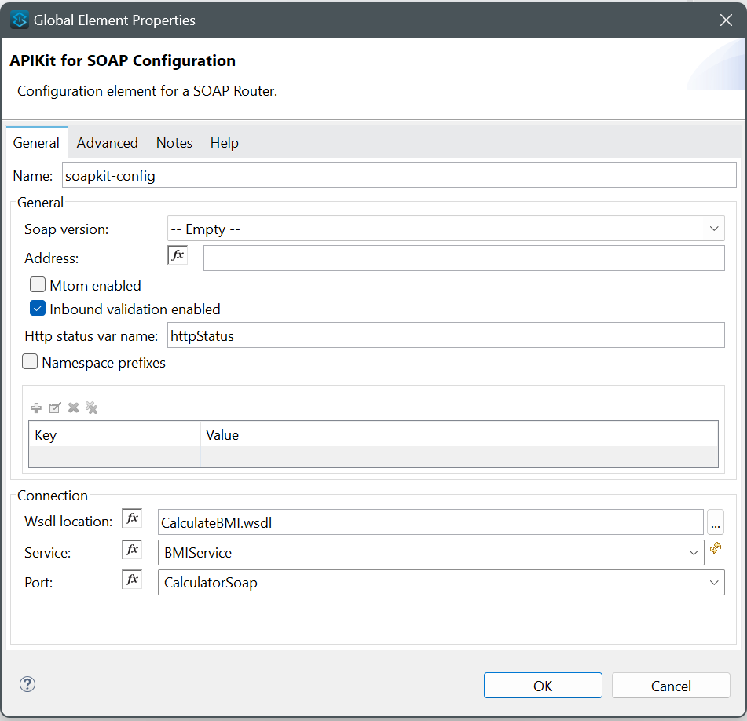

Steps For creating Soap-Based Web Service Using Mulesoft:
- Create a new Mule project based on a SOAP API specification.
In Anypoint Studio, from File, select New > Mule Project.
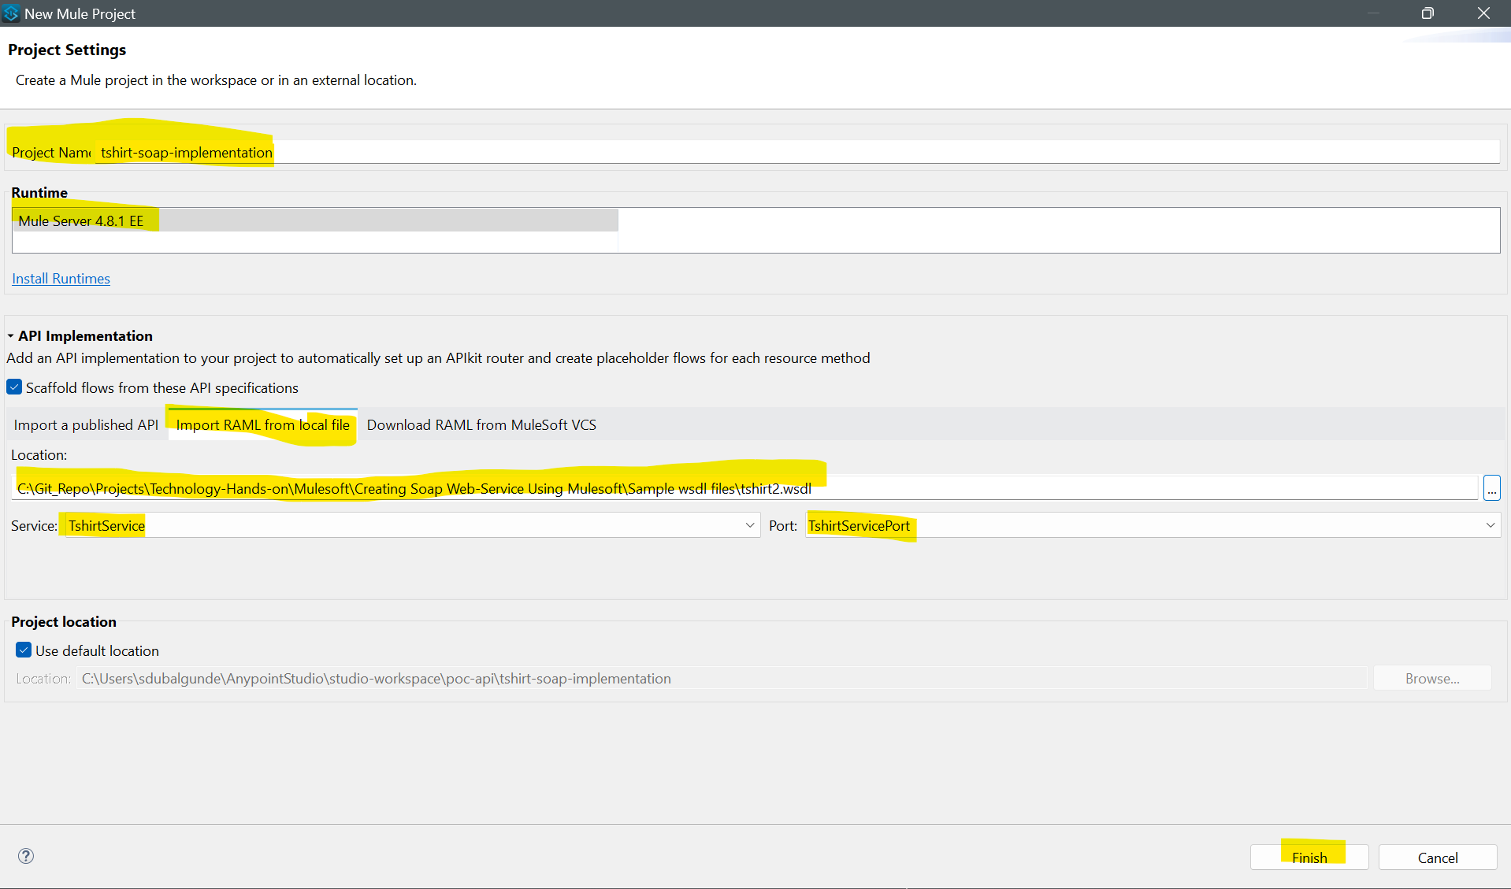
- After providing project name,runtime version,and importing wsdl file we will see service and port fetched from the imported wsdl file then click Finish button to create a Soap-Based API.
- Once Soap-Based API project gets created in anypoint studio,we will see below things
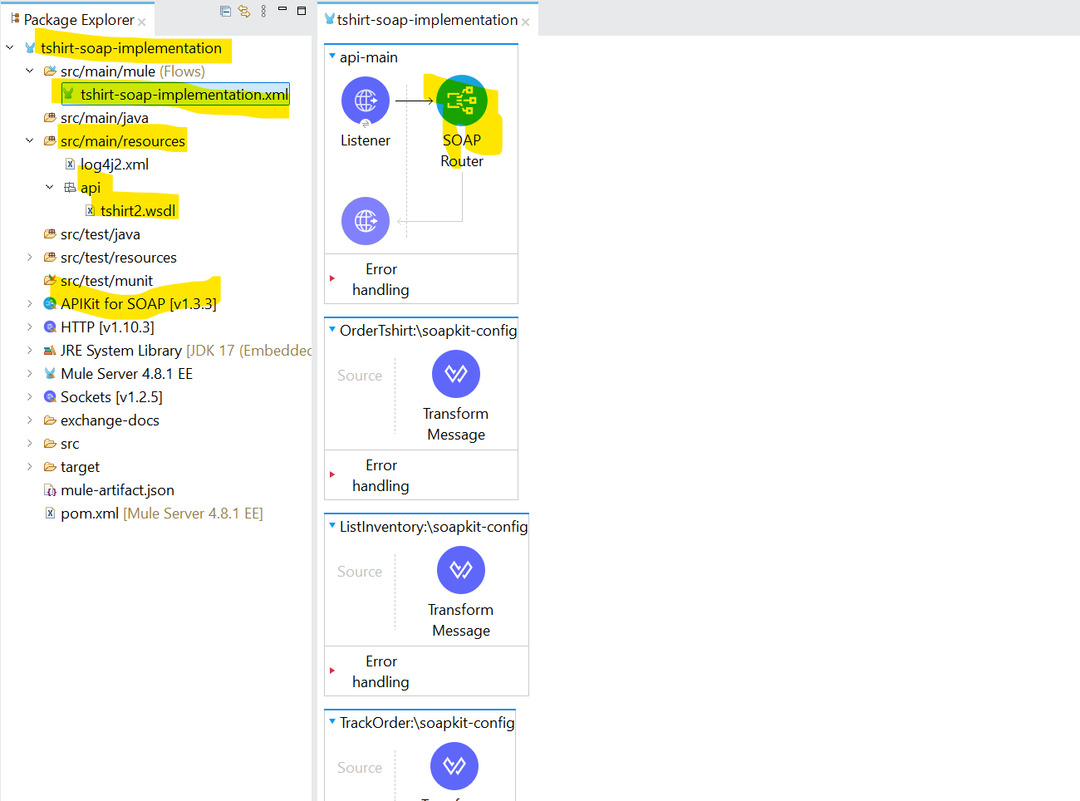
4)You will see your provided wsdl file gets placed in src/main/resources/api folder and the implementation file is generated with project name under src/main/mule that been provided while creating project.
5)To test and see if everything is imported successfully and project is running, we can Right-click a blank area of the canvas and select Run Project in Anypoint Studio.
6)Once you see Application deployed log in Anypoint Studio’s console , you can trigger a request to fetch the wsdl file by triggering a request to below endpoint in either Soap UI client or Postman

http://localhost:8081/TshirtService/TshirtServicePort?wsdl
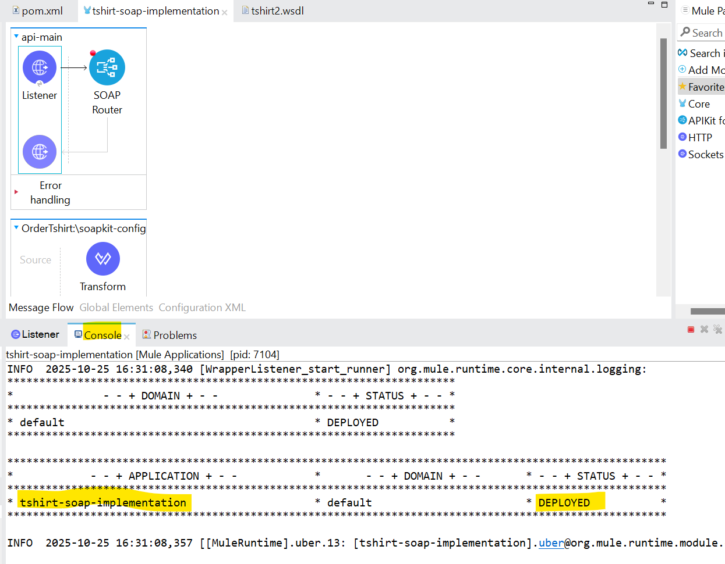
postman
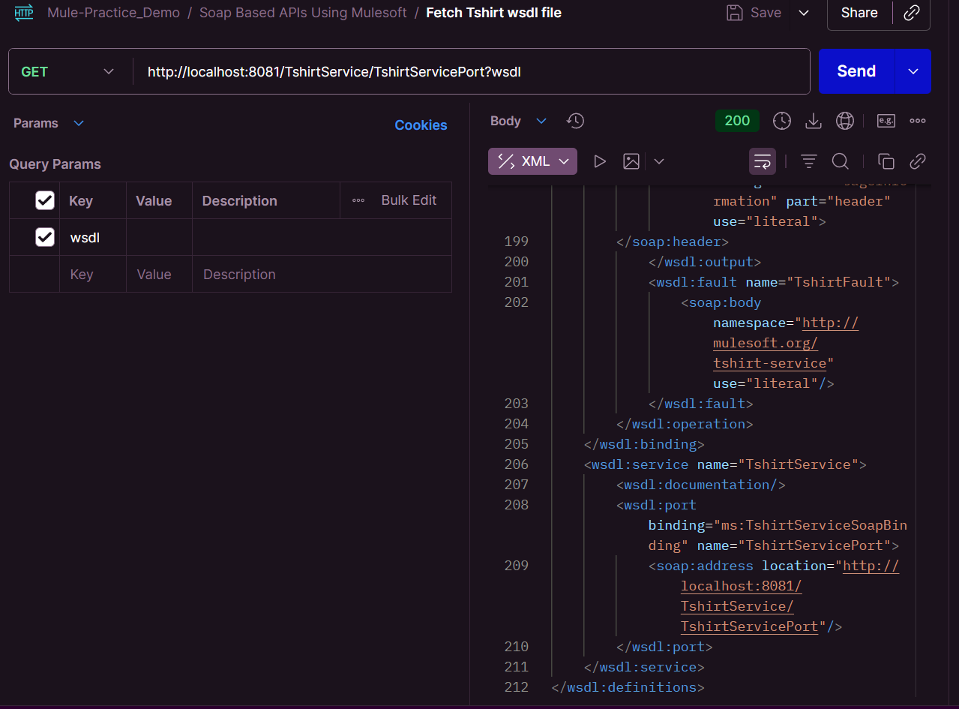
Soap UI
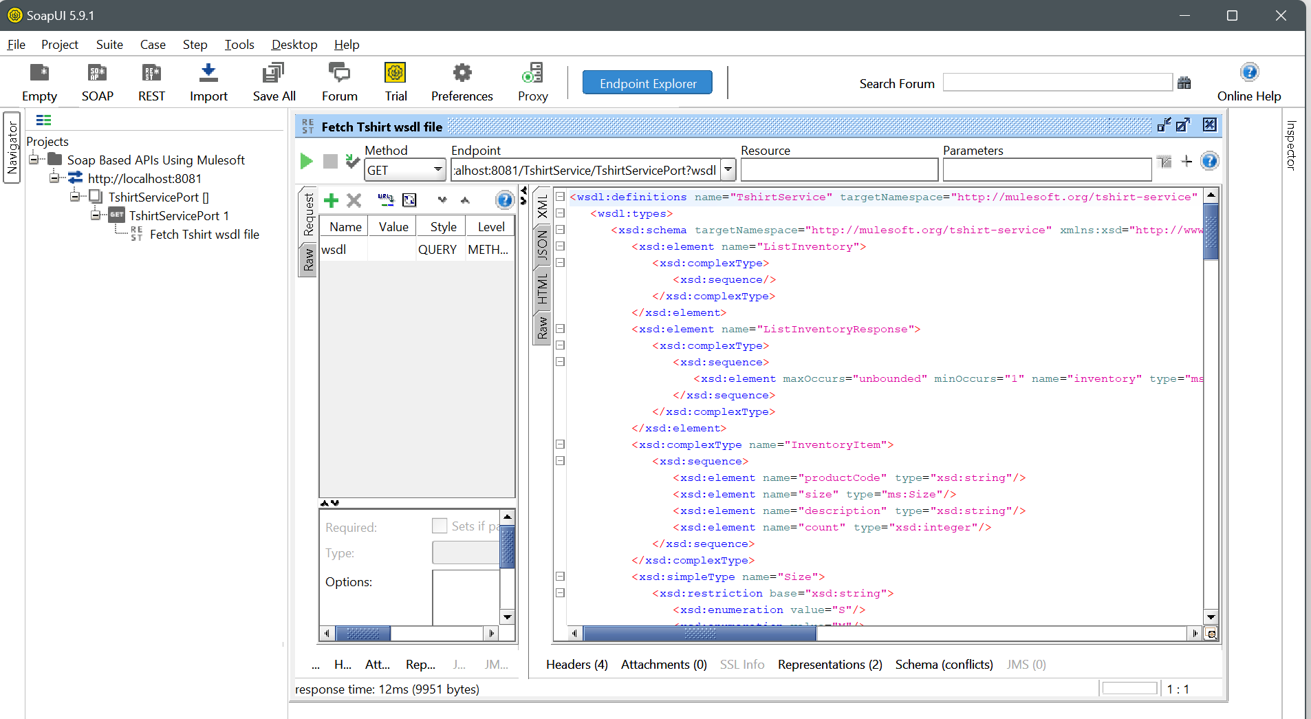

If you update your WSDL file, regenerate your flows by right-clicking your WSDL file and selecting Mule > Generate Flows From WSDL.

